

Auto Subtitle on PowerPoint for Flipped Sessions
- Open MS PowerPoint program
- Click “Slide Show” [Fig. 1]
- Click “Always Use Subtitles” [Fig. 1]
Fig. 1
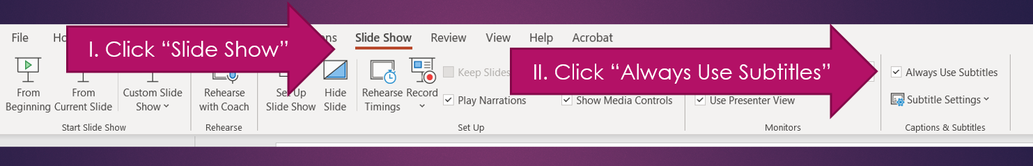

- Open Video Recording Platform – The following are steps for Zoom
- Click “Host” [Fig. 2]
- Choose “With Video On” or “With Video Off” [Fig. 2]
Fig. 2
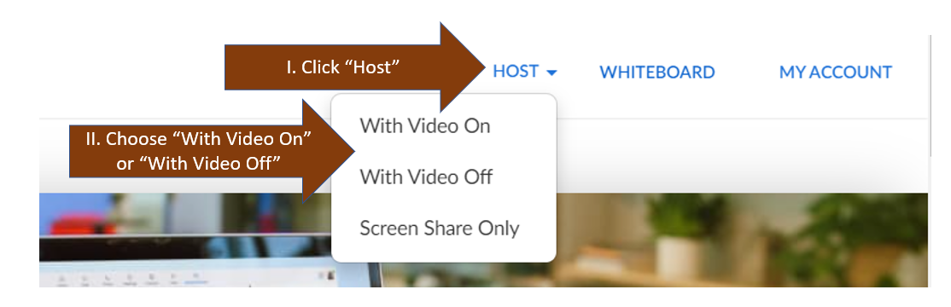

- Click “Open Zoom Meetings”
- Click “Launch Meeting”
- Click “Join with Computer Audio” IF window pops up
- Click “Slide Show” on PowerPoint [Fig. 3]

Fig. 3
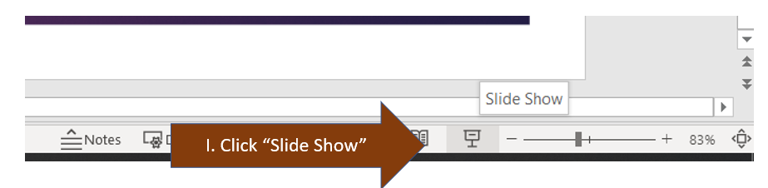

- Click “Share Screen” on Zoom

Warning: IF you have multiple screens, choose the appropriate screen that displays the closed captioning. [Fig. 4]

Fig. 4
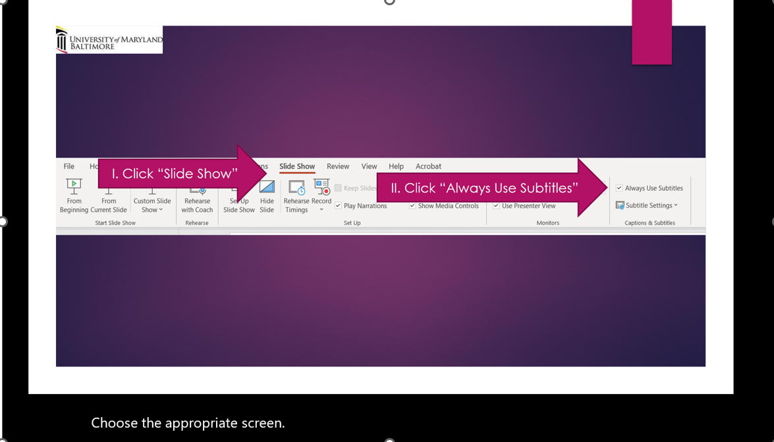

- Mouse over the control panel of Zoom
- Click the three horizonal dots “More”
- Click “Record”

Once done recording:
- Mouse over the control panel of Zoom
- Click the three horizonal dots “More”
- Click “Stop Recording”
- Wait for the recording to be saved at a folder
- Rename the MP4 accordingly
- Upload the MP4 to the learning management system

